Assessment Study Guide

Vocabulary: Choose and highlight the correct bold term or lettered item:
- If your grandparents accompany you on vacation, do they go with you or stay home?
- If you are a “Close Reader”, is reading an article one time adequate or inadequate?
- If you jump up and down when you get great news, are you emphasizing or deemphasizing your happiness?
- If you want to imply to someone that their locker is too full, would you say:
  - You may want to organize your locker a little bit.
  - Your locker is a pig sty! Clean it out now!
- If you were mutually working on your science project, would be putting in equal or unequal amounts of time?

Context Clues: Concisely highlight the context clues in each example. Determine the meaning of the bold vocabulary words and explain your reasoning.

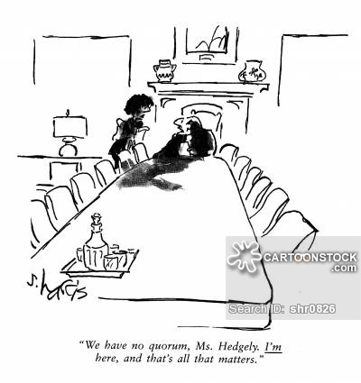
- Not until there was a quorum at the meeting could the important vote be taken, and so those who had arrived early sat idly waiting for other members to arrive.
- We need five people to make a quorum for the meeting to officially count.
- The annual meeting requires that the quorum be no less than 30% of the official membership.
- There are not an adequate number of people present for the required quorum to hold the meeting in the cartoon, there is only one person present.

- I think quorum means _____________because

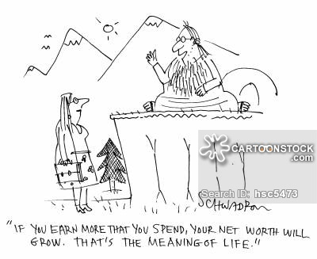
- Cesar has a knack for troubleshooting our electronic devices, so we called him the "gadget guru.”
- We all decided to take lessons from a yoga guru, because he knows more than we do about the correct way to hold the positions and breathe.
- Michael Jordan, Wilt Chamberlain, and Kevin Durant are considered gurus on the basketball court because they are the best in their field.
- Michelle Phan is considered the number one make up guru on YouTube with over 5.5 million subscribers.

- I think guru means ____________ because

Compound Sentences:

What purpose does each of the coordinating conjunctions below have when they connect two independent clauses? How does it explain the connection between the two clauses?

- And _______________________________
- Or _________________________________
- But _______________________________
- So ________________________________

In each set of sentences below, choose the correctly written compound sentence.

- Susie loves to read books, and she loves to do her homework.
Susie loves to read books and do her homework.
- Irene likes to draw but she dislikes painting canvasses.
Irene likes to draw, but she dislikes painting canvasses.
- Michael likes football and basketball.
Michael likes football, and he likes basketball.
- Everyone should go to bed early, so they are refreshed for the test.
Everyone should go to bed early so they are refreshed for the test.

- Yes No John went to the show but he forgot his money at home.
  - missing comma (before “but)
  - missing coordinating conjunction (FANBOYS)
  - missing subject
  - missing subject and verb
- Yes No The basketball players stretched, since they were warming up for the game.
  - missing comma
  - missing coordinating conjunction (FANBOYS)
  - missing subject
  - missing subject and verb
- Yes No The team will play together, or risk losing the game.
  - missing comma
  - missing coordinating conjunction (FANBOYS)
  - missing subject (they risk losing the game)
  - missing subject and verb
- Yes No The class focused during the test, so they did well.
  - missing comma
  - missing coordinating conjunction (FANBOYS)
  - missing subject
  - missing subject and verb
- Yes No I enjoyed the movie but my brother didn’t.
  - missing comma
  - missing coordinating conjunction (FANBOYS)
  - missing subject
  - missing subject and verb
- Yes No Finish your assignment today, or come back tomorrow for more help. (This has the understood “you” as the subject)
  - missing comma
  - missing coordinating conjunction (FANBOYS)
  - missing subject
  - missing subject and verb
- Yes No John went to the store, and the mall.
  - missing comma
  - missing coordinating conjunction (FANBOYS)
  - missing subject
  - missing subject and verb
- Yes No Always respect your elders, so you may earn their trust.
  - missing comma
  - missing coordinating conjunction (FANBOYS)
  - missing subject
  - missing subject and verb

- John likes video games, ____________ he likes reading.
I chose _________ because
- Jill didn’t show up on time, __________ she didn’t get to eat any of the pizza at the party.
I chose _____________ because
- My mom will sleep in on Saturday, ______________ she will get up to go to the Farmer’s Market.
I chose ________ because _
- Sally wanted to stay at the dance, __________ she didn’t stay very long.
I chose __________ because
Create your own compound sentences using the four coordinating conjunctions (FANBOYS) below:
- and
- or
- but
- so

